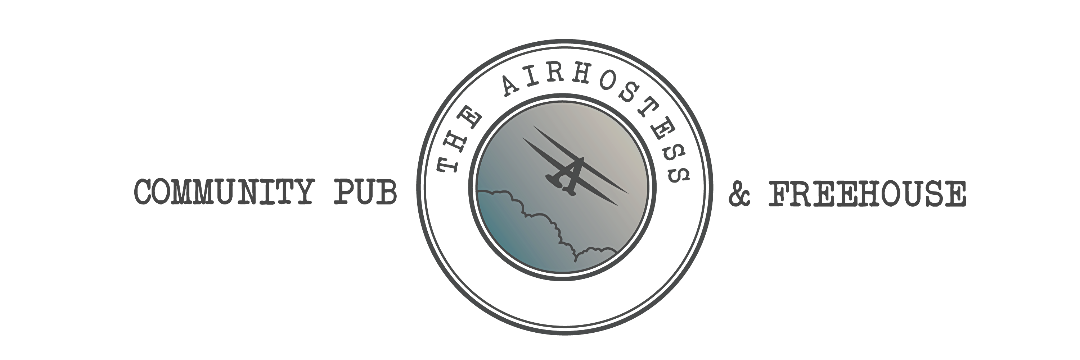

- SUNDAY MENU -
APPETISERS
Marinated Olives and Feta Cheese (v, nf, gf) £5.95
Mini Sourdough Baguettes with a trio of Whipped, Flavoured Butters (v, nf) £6.95
STARTERS
Homemade Soup of the Day with a Rustic Bread Roll (v, gf*) £6.50
Bloody Mary Crayfish Crumpet (nf) £7.95
Tempura Tofu Tacos with Spring Onion, Radish, Pickled Red Cabbage and Sticky Soy Dressing (vg, df) £7.50
Burrata with Sweet & Sour Tomatoes, Pine Nut Crumb and Basil (v, gf, nf*) £9.95
Grilled Sardines on Toast, with Lemon Zest, Olive Oil and Sea Salt. (df, nf, gf*) £7.95
Grilled Chorizo Bites with Confit Garlic in Oil with Crusty Bread (df, nf) £10.95
MAINS
Dishes marked with 2 prices are available as a Standard or Light Portion
Traditional Lasagne with Parmesan, Rocket, Roasted Vine Tomatoes and Garlic Bread (nf) £11.50 / £15.50
Beer Battered Haddock and Chips with Mushy or Garden Peas (nf, df) £14.50 / £18.95
Scampi and Chips with Mushy or Garden Peas (nf) £12.50 / £16.50
Spiced Bhaji Burger on a Toasted Brioche Bun with Gem Lettuce, Mango Chutney, and Mint Yoghurt
served with Chips (vg*, v* df, nf, gf*) £14.50
Vegetable Lasagne with Rocket, Roasted Vine Tomatoes and Garlic Bread (v, nf) £10.95 / £14.95
8^{oz} Gammon Steak with Egg, Pineapple, Chips and Peas (gf, nf, df) £16.50
Chorizo, Prawn and Chilli Linguine with Fresh Basil, Parmesan, Mascarpone and Garlic Bread (nf) £16.50
Baked Goats Cheese Salad with Mixed Summer Berries, Beetroot, Walnuts and Honey (v, gf, nf*) £16.50
King Prawns with Cherry Tomato and Radish Salad, and Marie Rose Sauce
with White Bread and Butter (df*) £16.50
STEAKS
Choose from our prime Derbyshire Steaks, all served with Chips, Roa1st Mushroom,
Balsamic Tomato and Watercress (gf, nf, df)
10^{oz} Rump Steak £21.95
8^{oz} Sirloin Steak £24.95
12^{oz} Rib Eye Steak £29.50
8^{oz} Fillet Steak £31.50

(gf) gluten free (df) dairy free (nf) nut free (v) veggie (vg) Vegan *available on request
Please let a member of staff know if you have and food allergies or dietary requirements. All items subject to availability.

A service charge is not included and is entirely at your discretion. All gratuities are shared equally between the bar, waiting and kitchen staff
The Air Hostess, Stanstead Avenue, Tollerton, Nottingham, NG12 4EA
t: 0115 648 0439 f: @theairhostesstollerton e: info@theairhostesstollerton.co.uk w: www.theairhostesstollerton.co.uk

- SUNDAY MENU -
ROASTS
Dishes marked with 2 prices are available as a Standard or Light Portion
Derbyshire Sirloin of Beef - £16.50 / £20.95
Maple Roast Turkey Crown - £14.50 / £18.95
Derbyshire Loin of Pork - £14.50 / £18.95
All served with Roast and Mashed Potatoes, Yorkshire Pudding, Sage and Onion Stuffing, Carrot, Tenderstem Broccoli, Garden Peas, Cavolo Nero, Roast Parsnip, Cauliflower in a Cheese and Beer Sauce topped
with Parmesan and Crispy Onions and a rich Home-made Gravy
Cauliflower Steak - £17.95
Served with Roast and Mashed Potatoes, Yorkshire Pudding, Sage and Onion Stuffing, Carrot, Tenderstem Broccoli, Garden Peas, Panfried Leeks, Roast Parsnip, Cauliflower in a Cheese and Beer Sauce topped
with Parmesan and Crispy Onions and a rich Home-made Gravy (v)

SIDES
Chips £4.00
Cheesy Chips £4.50
Rosemary, Truffle Oil and Parmesan Chips £4.95
Garlic Ciabatta £4.00
Cheesy Garlic Ciabatta £4.50
Beer Battered Onion Rings £3.00

Rocket, Tomato and Parmesan Salad £4.00
Side Salad £3.50
Pepper Sauce £2.50
Port & Stilton Sauce £3.00
Devils Sauce £3.00
Lemon

(gf) gluten free (df) dairy free (nf) nut free (v) veggie (vg) Vegan *available on request
Please let a member of staff know if you have and food allergies or dietary requirements. All items subject to availability.
If you have any issues with your visit here, please talk to us as we can rectify any problems whereas TripAdvisor can’t
The Air Hostess, Stanstead Avenue, Tollerton, Nottingham, NG12 4EA
t: 0115 648 0439 f: @theairhostesstollerton e: info@theairhostesstollerton.co.uk w: www.theairhostesstollerton.co.uk

